Group ID : ITP-2018-MLB-G1-08

Title : Management System for Orocare Toothpaste Company

**Project Introduction**

As the title suggests this project is based on a Management System Software made for a Toothpaste Company named Orocare using Java,Sql,MySql technologies.The goal of this management system is to automate the major functions of the company which are currently done manually.Therefore we have divided the main functions into 8 categories.They are,

* **User & Customer management -** Crud functions to store and manipulate User and Customer information,User Login,Granting different user level permissions,etc.
* **Stock & Notification management -** Crud functions to store and manipulate Stock data,Notifications related to the status of the stock,User activity and alerts,etc.
* **Product & Finance management -** Crud functions to store and manipulate Product and Finance information,Calculation of income and expenses monthly,etc.
* **Sales & Order management -** Crud functions to store and manipulate Sales and Order information,Managing of internal and external sales,etc.
* **Employee salary & Utility management -** Crud functions to store and manipulate Employee salary & Utility information,etc.
* **Employee Management -** Crud functions to store and manipulate Employee details,etc.
* **Supplier Information management -** Crud functions to store and manipulate Supplier Information,etc.
* **Supplier Order management -** Crud functions to store and manipulate Supplier Order information,etc.

The client will have access to each function by using the main Dashboard after logging in through a valid user account.All functions will have connection to the database.

**Main Interfaces**

Main Dashboard

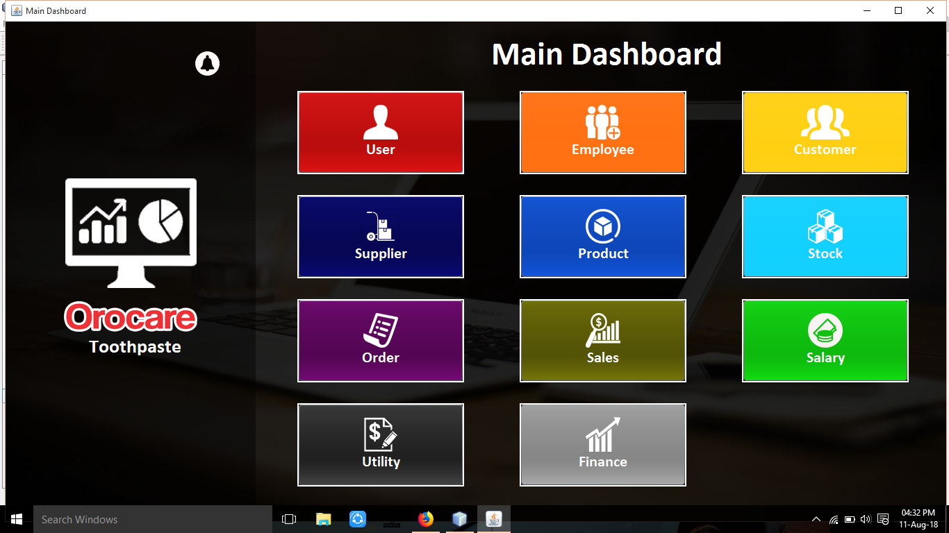

Login UI

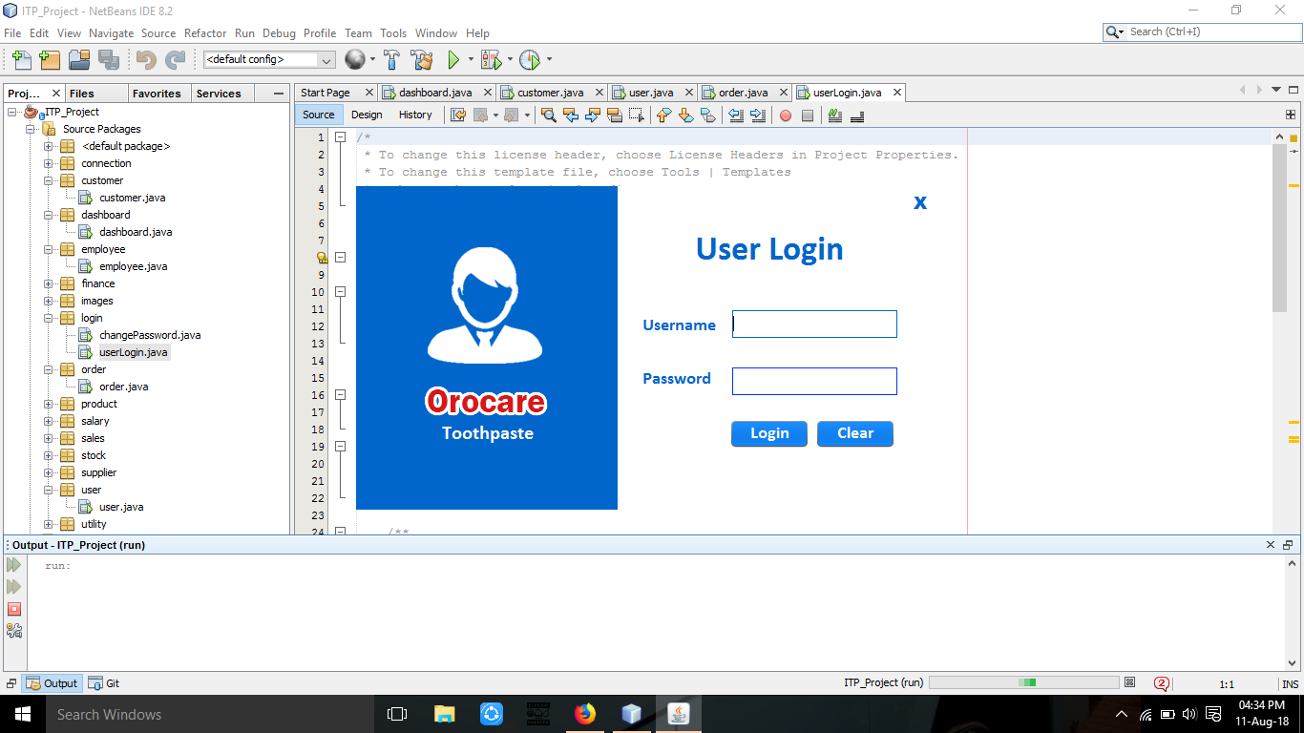

Change Password UI

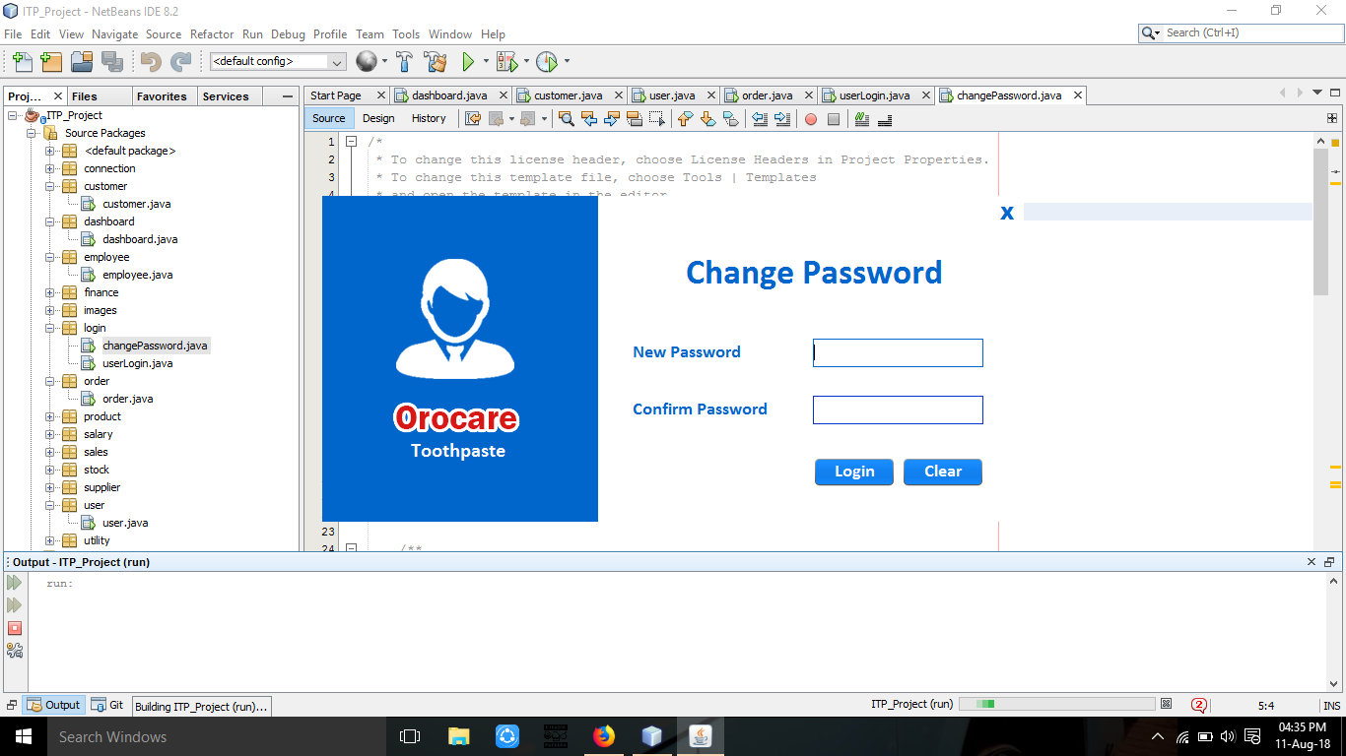

Employee Management

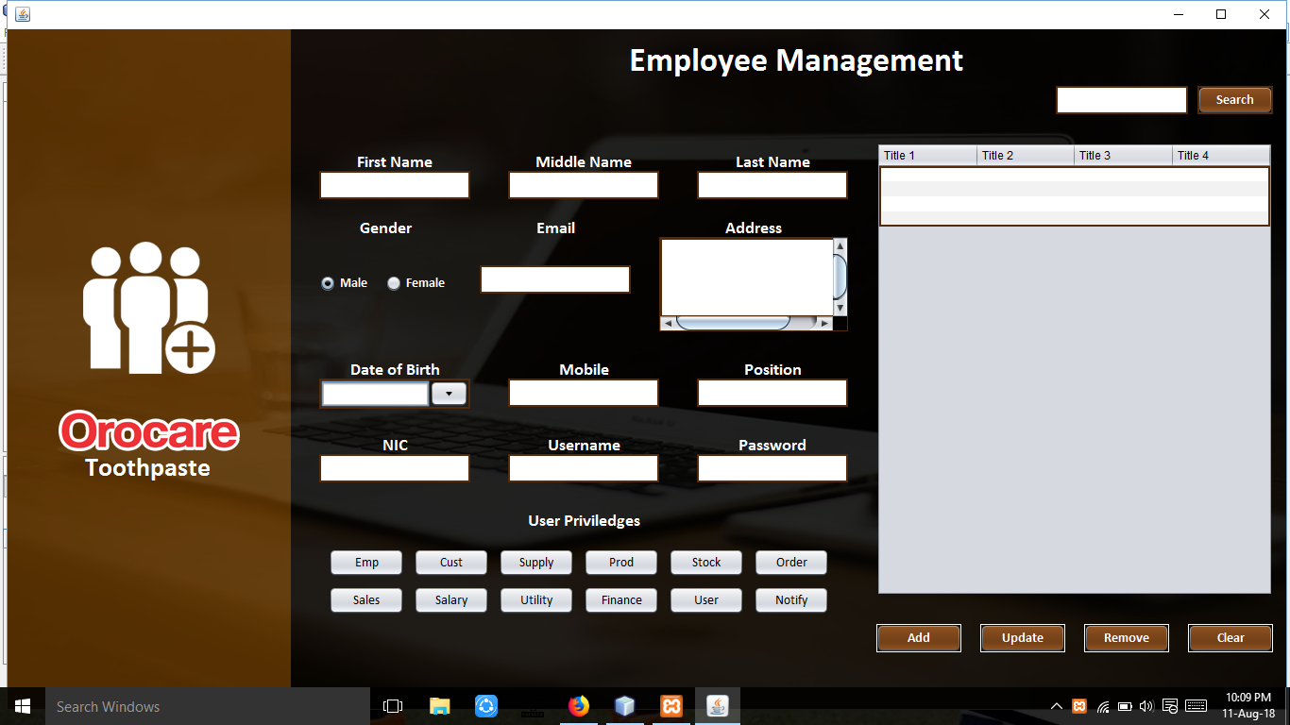

User Management

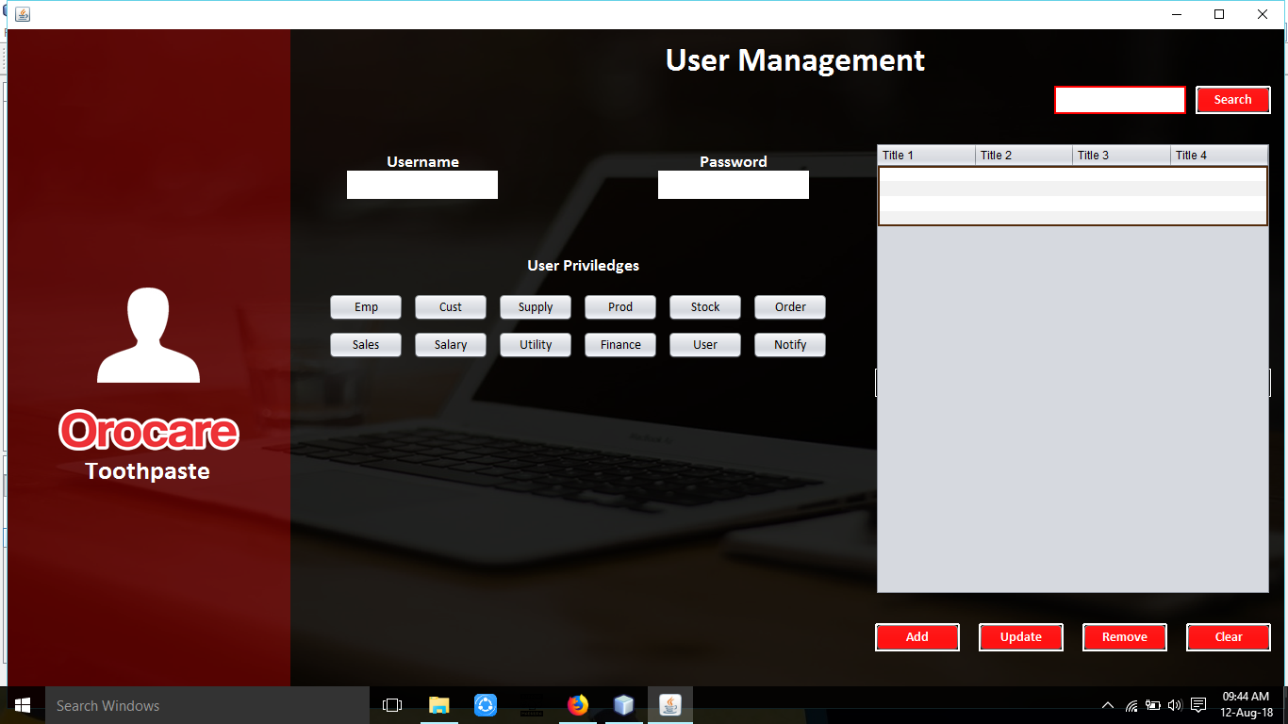

Customer Management

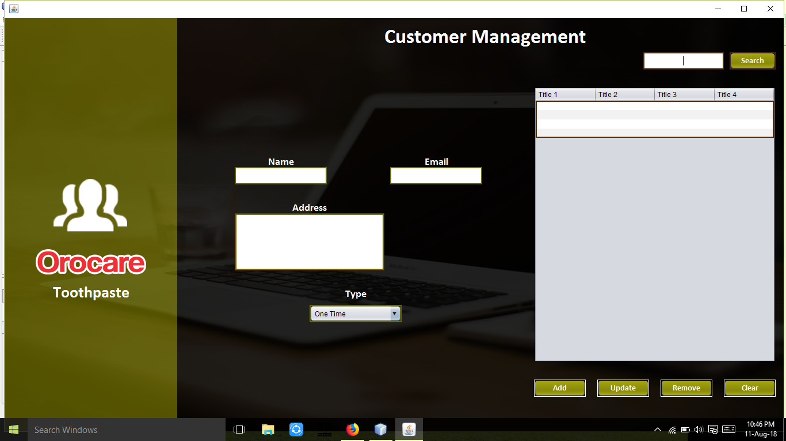

Product Management

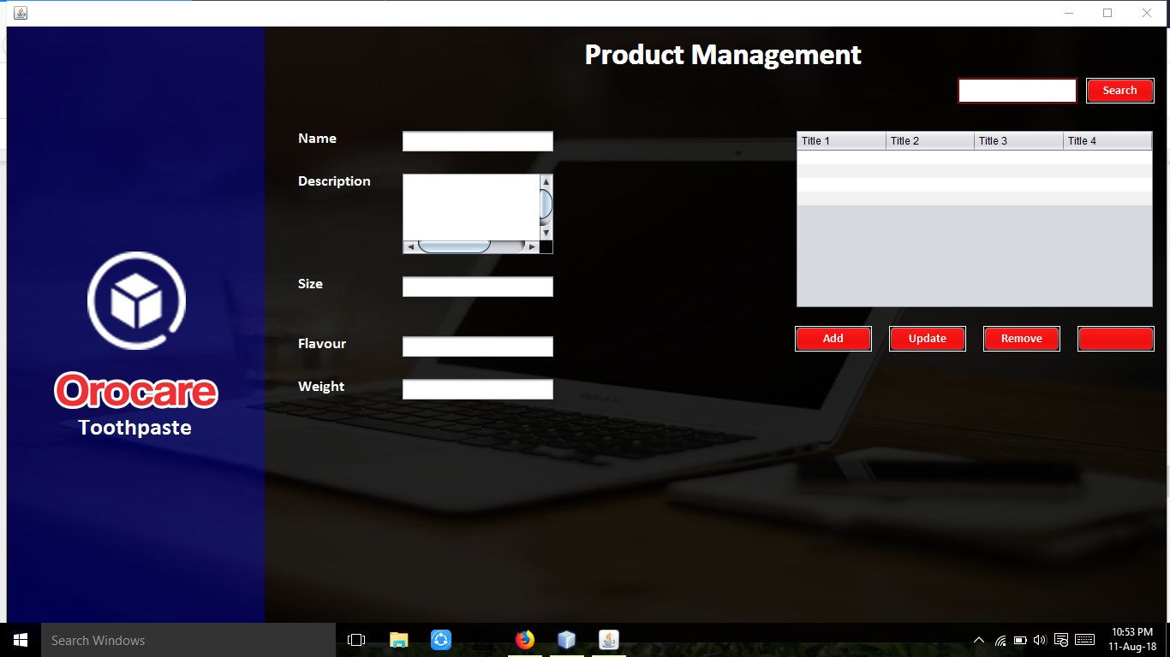

Salary Management

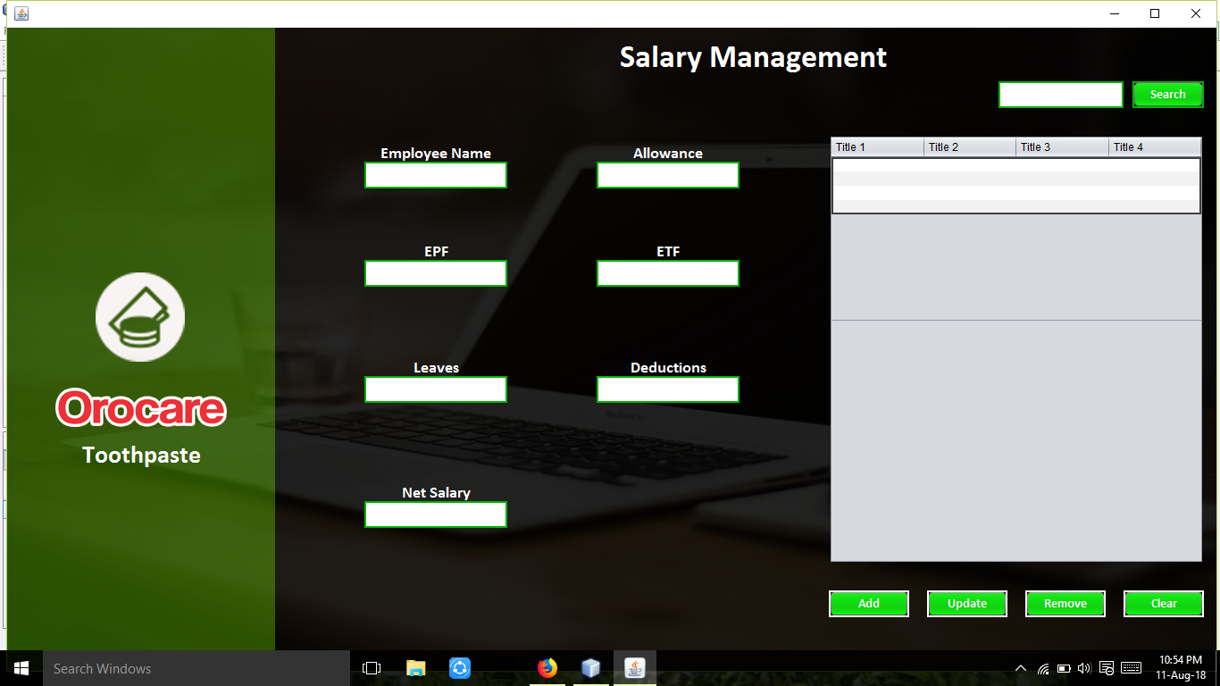

Sales Management

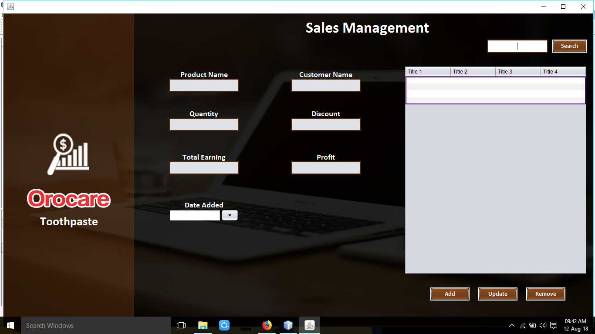

Order Management

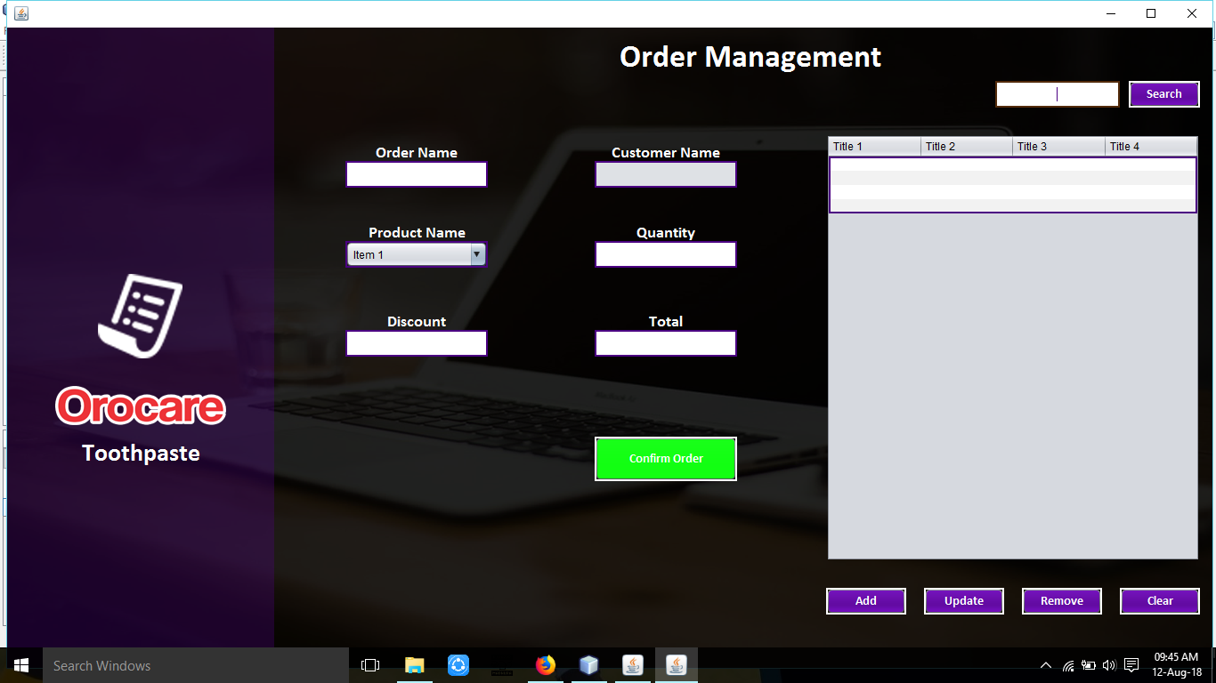

Utility Management

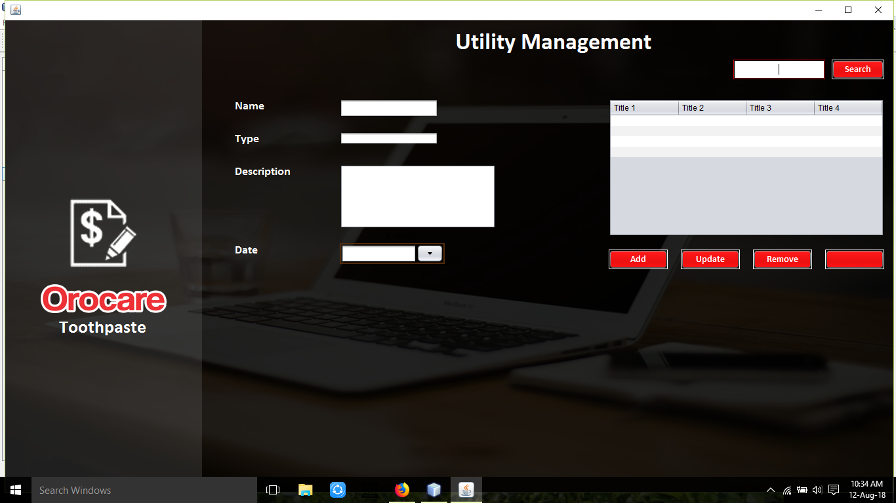

Supplier Management

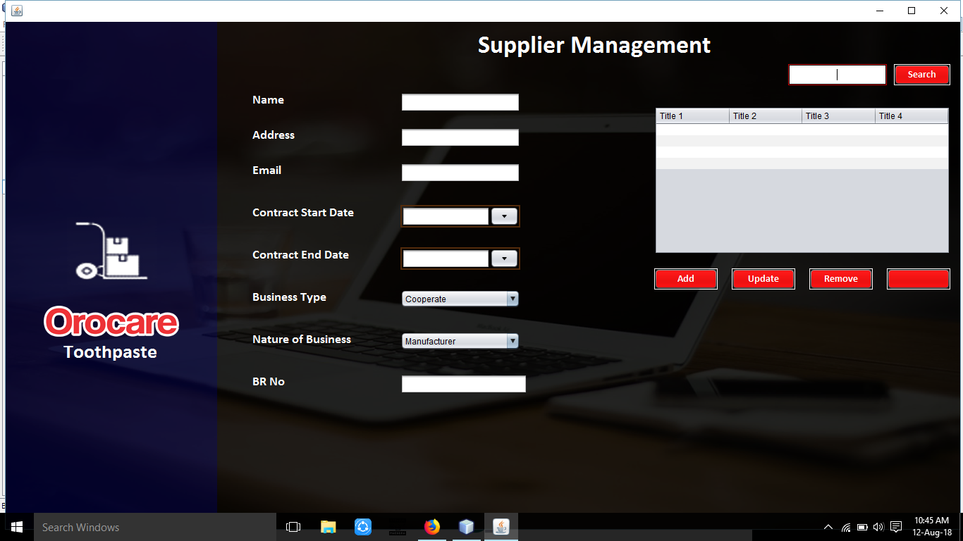

**Class Diagram**

